Cousera Stats – Ch 2.1, 2.2

2.1 – Defining Probability

In applications, probability is framed in terms of a **random process** that gives rise to an **outcome** (such as, a die will randomly fall on numbers 1-6. What is the probability that a die will land on 2?)

**Probability** – the probability of an outcome is the proportion of times the outcome would occur if we observed the random process an infinite number of times.  
 always defined as a proportion between 0 and 1 or as a percentage between 0% and 100%

Law of Large Numbers – As more observations are collected, the proportion *pn* of occurrences with a particular outcome converges to the true probability *p* of that outcome.

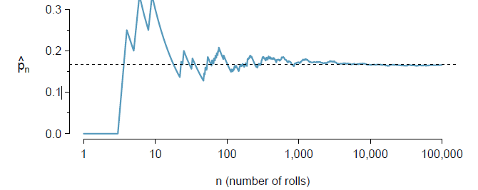

**Notation**: *P(A)* is the probability of instance *A* occurring.

**Mutually Exclusive:** outcomes that cannot happen simultaneously (such as rolling a 1 and a 2 on the same die at the same time.) Also known as disjoint outcomes.

**Addition Rule of Disjoint Outcomes**: If A1 and A2 represent two disjoint outcomes, then the probability that one of them occurs is described as *P*(*A1* or *A2*) = *P*(*A1*) + P(*A2*)

**Events:** A set of occurances (such as rolling a die 100 times, set X could be the collection of times 1 was rolled.) Sets of occurences are written as X = {1}

**General Addition Rule:**  If A and B are any two events, disjoint or otherwise, then the probability that at least one of them will occur is *P*(*A* or *B*) = *P*(*A*) + *P*(*B*) – *P*(*A* and *B*) where *P*(*A* and *B*) is the probability that both events will occur.

**Probability Distribution:** A table of all disjoint outcomes and their associated probabilities.  
 Rule 1: all outcomes must be disjoint  
 Rule 2: each probability must be between 0 and 1  
 Rule 3: all probabilities combined must equal 1

**Compliment of an event:**  The probability that something does *not* occur. Denoted as *Ac*  
 Properties: *P*(*A* or *Ac*) = *P*(*A*) + *P*(*Ac*) = 1

**Independence:** Two processes are independent if knowing the outcome of one provides no useful information about the outcome of the other. (such as rolling a die while flipping a coin.)

**Multiplication Rule:** If *A* and *B* represent events from two different and independent processes, then the probability that both *A* and *B* occur can be calculated as the product of their separate probabilities: *P*(*A* and *B*) = *P*(*A*) * *P*(*B*)

2.2 Conditional Probability

**Marginal Probability:** a probability based on a single variable without regard to any other variable.

**Joint Probability:**  a probability of outcomes for two or more variables or processes.

**Conditional Probability:** The conditional probability of the outcome of interest *A* given condition *B* is computed as the following: *P*(*A* | *B*) = (*P*(*A* and *B*))/*P*(*B*)

**General Multiplication Rule:** If A and B represent two outcomes or events, then *P*(*A* and *B*) = *P*(*A*|*B) * P*(*B*). Where *A* is the outcome of interest and *B* is a condition.

**Sum of Conditional Probabilities:** Let *A1, A2, …, Ak* represent all disjoint outcomes for a variable or process. Then if *B* is an event, possibly for another variable or process, we have *P(A1*|*B)* + … + *P(Ak*|*B)*  = 1. The rule for compliments also holds when an event and its complement are conditional on the same information: *P(A*|*B) =* 1 – *P(Ac*|*B)*

**Bayes’ Theorem of inverted probabilities:** Consider the following conditional probability for variable 1 and 2: *P*(Outcome *A*1 of variable 1 | Outcome *B* of variable 2). Bayes’ Theorem states that this conditional probability can be identified as the following fraction:

$$x=\frac{P(B|A1)P(A1)}{P\left(B | A1\right)P\left(A1\right)+P\left(B | A2\right)P\left(A2\right)+…+P\left(B | Ak\right)P(Ak)}$$

**Application of Bayes’ Theorem**

Jose visits campus every Thursday evening. However,

some days the parking garage is full, often due to college events. There are academic

events on 35% of evenings, sporting events on 20% of evenings, and no events on 45%

of evenings. When there is an academic event, the garage _lls up about 25% of the

time, and it _lls up 70% of evenings with sporting events. On evenings when there

are no events, it only _lls up about 5% of the time. If Jose comes to campus and

_nds the garage full, what is the probability that there is a sporting event? Use a

tree diagram to solve this problem

P(sporting | full) = P(full and sport)/P(full) = 0.14/(0.0225+0.14+0.0875) = 0.14/0.25 = 0.56